So you want a VoIP
phone service?

COMMUNICATIONS ALLIANCE
CUSTOMER BOOKLET

The seven steps to VoIP

So you have heard about VoIP but you don’t know whether it is for you or you don’t know where to start … read on.
The following steps lead you through the main topics when considering a VoIP service in your home or a small office. Further information, including resources to assist you in answering your questions, can be found in each section of the booklet.

Why do you want a VoIP phone service?  - are you looking for cost savings?  - need more phone lines?  - interested in more telephone features? | 1
Issues to consider  Do you understand the differences between your traditional telephone service and a VoIP service?  For example  - how does it fit in with your existing phone setup?  - what happens to your phone number?  - 000 – fire brigade, police, ambulance?  - what about contracts and phone bills?  - what is the voice quality like? | 2
Ensuring that your broadband is up to it  - if you do not have broadband, then you need to get it.  - to help you decide, shop around. Ask friends about their experiences. Check out a few websites.  - if you already have broadband, then you need to make sure that it is suitable for VoIP. | 3

Deciding on a VoIP service provider  - again you need to shop around. Ask friends about their experiences and check out the websites.  - maybe you want a ‘bundled’ package where the broadband and VoIP services are supplied from the same provider. | 4
Connecting it all up  - there are a few options in setting up a VoIP service. You can use your current phone or purchase a new VoIP phone. VoIP services can be used on wireless and cordless phones. | 5
Using your VoIP service  - currently there isn’t a centralised directory for all VoIP numbers or centralised directory assistance for those using VoIP services.  - making and receiving calls will be very familiar. As with cordless phones and some other phones, you need power for the service to work.  - if you have a problem with the VoIP service, there are few more issues to consider. | 6
Customer service and your rights  - like all phone services you need to know who to contact for customer service.  - in Australia, consumers have certain rights when using a telephone. | 7

Introduction

Who needs to read this booklet?
There is a lot of practical advice is this booklet which can also be applied to your current phone service as well.
This booklet is for someone who has little or no knowledge of VoIP to guide them through a number of steps when choosing a VoIP phone service for their home or office.
It is for VoIP services in residential homes, small offices or working from home. The questions are designed to help you compare VoIP services with your existing phone service.

Australian made
In considering the questions being asked on the following pages, just choose the ones that are relevant to you.
If you have already started looking on the internet, you will quickly realise that there is no shortage of information about VoIP. The information in this booklet has been written for the Australian market. It covers many aspects that are relevant for a first-time purchaser of a VoIP service.
This booklet does not attempt to answer every question but where possible provides guidance and where to go for further information.

So what is VoIP?
Your traditional telephone service supplied by your telephone company uses a process that has been around for over a hundred years, sometimes referred to as the Plain Old Telephone Service, or ‘POTS’ for short. Over that time it has become a very reliable and extraordinarily simple service to use, being able to communicate with anyone in the world at any time right from your own home.
VoIP is a relatively new technology used to provide a telephone service that digitises your conversation and chops it up into packets and sends it more efficiently over the public Internet network using the same technology that has given us the Internet, hence ‘VoIP’ or ‘Voice over Internet (Protocol)’.

Unlike POTS, a VoIP service depends on many components to work properly – your phone, your home network, your broadband connection to the internet, your VoIP service provider and the internet itself. No wonder there is a little more to consider.
On the other hand, with this complexity comes the possibility of a new range of services and devices that are available for individuals to use from their homes and offices. These VoIP services provide new and innovative features for everyone. At the same time, many features that have traditionally been provided may not be available with these newer VoIP services.

A quick word about VoIP programs on computers
In addition to VoIP phone services, there are many VoIP programs that can be loaded onto a computer and used like a software version of a telephone. Three of the most common are Skype™, Google Talk and MSN Messenger (Windows Live™ Messenger).
What will become apparent to you as you read the information in this booklet is that there are many other components that come with a telephone service (whether you are aware of all of them or not) that may not be covered by these VoIP computer programs (just check out the consumer protection section of this booklet later on).
As with all services, there are tradeoffs in what features you need or want and what you are willing to pay for them. Hopefully this booklet will provide enough guidance to assist you in making that decision.
In a rapidly evolving industry, new equipment and new services are being introduced all the time.
What may have not been available at the time of publication of this booklet might be available by the time you are reading this.
Talk to the providers and use the references in this booklet to be across the latest information and developments.

Terms used in this booklet
VoIP service (or VoIP phone service)
A voice communication service that is supplied by a VoIP service provider over your connection to the Internet, typically broadband.
ISP – Internet Service Provider
A company (or business) that provides access to the Internet. In this booklet the term is used for those ISPs who provide a broadband service (also called a Broadband Service Provider).
POTS – Plain Old Telephone Service
The traditional telephone service which has been around for over one hundred years and not long after the first demonstration of a telephone by Antonio Meucci in New York in 1860.
In some countries the term originally stood for ‘Post Office Telephone Service’ when the national post offices (the PMG in Australia) looked after the telephone service as well.
Other terms
ACIF Australian Communications Industry Forum
ACMA Australian Communications and Media Authority
ADSL Asymmetrical Digital Subscriber Line
ATA Analogue Telephone Adaptor
CSG Customer Service Guarantee
DCITA Department of Communications, Information Technology and the Arts
kb/s kilobits per second - the speed at which the information travels
MB megabytes (a million bytes) – the quantity of information
NRS National Relay Service
QoS Quality of Service
TIO Telecommunications Industry Ombudsman
TTY Text telephone (teletypewriter)

1 Why do you want a VoIP phone service?

There are a number of things to think about as you make a decision whether or not to use a VoIP service. On a broad level, think about the following questions as you are reading the booklet:
- What type of phone calls do you make today?
- What kinds of communications (voice and otherwise, including text and video) do you want to make in the future?
- What equipment do you want to use (i.e. your existing phones or new types of equipment)?
- How do you want to use the equipment (fixed, mobile or attached to a computer)?
- What is your personal computer and broadband usage like today?

There are three common reasons for purchasing a VoIP service:

Cost savings
VoIP calls can allow for cost savings. Questions to ask are:
Typical reasons for choosing a VoIP service are for cheaper international calls and national long-distance calls.
Calls to other people using the same VoIP service (called ‘on-net’ calls) are typically without charge.
- What are the costs of having a VoIP service and how do they compare to my current costs?
- What are the upfront costs including the equipment and possible activation costs?
- What are the monthly fees?
- What are the charges for of the different types of calls (local, long distance, mobile, international)?
- Will having a VoIP service increase my broadband bill?
- Are there any costs for people calling my VoIP service?

Need more phone lines?
An account with a VoIP service provider can deliver more than one VoIP service. Questions to ask are:
- How many ‘phone lines’ can I get?
There are reasons that you need to consider in keeping a phone that is powered by the network, such as for backup in case of a power failure.
If your broadband is ADSL then you still need your current phone line for it to work.
Read Section 2 ‘Things to consider’ to help you decide.
- How many calls can I make and receive at the same time?
- How many ‘phone lines’ can my broadband support?
- Do I need to keep my existing POTS phone line? Are there other rental plans that would be most cost-effective while using a VoIP service?

More new telephone features?
There are many services and their availability depends on what is provided by the VoIP service provider. Some services that you may wish to enquire about are:
- voicemail messages (like an answering machine).
Many of these services are not unique to VoIP. Some may already be included in the VoIP service for free.
As an example, your voicemail messages may be accessed via your phone, logging in to the VoIP service provider’s website or even as an attachment in an email.
- call waiting, call forwarding, call barring.
- conference calls.
- instant messaging (IM).
- video calls.
- ability to send text or visual information during a call.
- higher quality voice calls.
- using your VoIP service wherever you are (nomadicity).
- presence (status of your availability to take calls and the availability of the person you are calling).
- sending and receiving faxes.
- ability to send and receive real-time text and video during a call.
Things to consider:
- What type of telephone or equipment do I require to use the service, e.g. a computer, a traditional handset, a dedicated VoIP handset? The ability to use a service will also depend on the equipment used by the person that you are calling.

2 Issues to consider
There are many aspects in using a telephone that most people take for granted. The following questions will help you though a number of these from the perspective of using a VoIP service.

Call quality
- Will the quality of the VoIP service be the same as what I am used to?
- If my VoIP service is connected to a network in my home or business, will it be affected by other activity on the network (for example file sharing or streaming)?
Factors leading to a degraded service may include how your home network and how the service provider’s network prioritises your calls.
There may also be incompatibilities between different pieces of customers’ equipment (and software).
- Under what circumstances can I expect my service to be degraded?
- Is there a preferred way to setup my modem and home network to optimise the quality of my calls?

Reliability
- Can I still make a call during a power outage or blackout (mains failure)?
If continued operation of your phone is important for your residence or business during a power outage, the use of a backup power supply (known as ‘UPS’ or ‘Uninterruptible Power Supply’) may need to be considered. A UPS operates like a backup battery and typically lasts for one or two hours.
- Should I keep my current telephone as a backup phone (e.g. one powered by the telephone line) or alternatively a mobile phone?

- VoIP phone services can operate independently from a networked computer in your home. Computers can be used to help in the set up process and to access the VoIP service provider’s website.
Unlike a VoIP phone service, using a VoIP program on a computer requires the computer to remain on at all times to receive calls using that VoIP service.
- Are there any guarantees that disruptions or faults with my service will be minimized or fixed quickly?

Emergency access
- Can I dial ‘000’ in an emergency to reach the fire brigade, police or ambulance?
Follow the instructions of the ‘000’ and ‘106’ operators. It is unlikely that they will be able to identify where you are just from your number.
- Will the ‘000’ emergency service operator know where I am?
- Can the service support real time text calls to the emergency service operator for ‘106’?
‘106’ is the emergency number provided by the NRS for those who are Deaf or have a hearing, speech or communication impairment.

Power supply
- What measures can I take if there is a power failure? See Section 6 for more information.

Phone numbers
- Do I get my own VoIP phone number?
Options include keeping your existing number or getting a new VoIP number. New numbers may be like your existing number or a ‘virtual’ (or ‘private’) number. Ask the VoIP service provider what is offered and what are the differences.
- Will I get a VoIP phone number that other people can call?
- Can I keep my existing ‘POTS’ phone number if I am changing to a VoIP service provider?
- Will I be able to keep my new VoIP phone number if I decide to change to a different VoIP service provider in the future?
- If I decide to go back to my provider of the POTS service, can I still keep my number?

Contracts and my bill
- Is there a contract that I have to enter into with my ISP? With my VoIP Service Provider?
- What are the billing arrangements?
- How are my bills paid — pre-paid or post-paid?
- Are my calls itemised on the bill?
- Is on-line (via the internet) payment of bills available?

Making calls
- Can I make calls to local, long distance, mobile, international numbers, ‘13’ and ‘1300’ local rate numbers, ‘1800’ free phone numbers, ‘1900’ premium rate numbers? Do I have to subscribe to make any of these calls?
‘13’ services (such as pizza deliveries and taxis) will not generally recognise where you are.

- Can I make calls to people using different VoIP service providers using my VoIP service? Can they call me?
It may be possible to use your phone (with supporting equipment) and the service wherever you can get access to the internet.
Generally, you can only ring POTS phone numbers and other people using the same VoIP service (called ‘on-net’ calls).
- Can I use the phone service in another location?
- Can I make a long distance call using an alternate service provider (also known as ‘pre-selection’)?
- Can I make a call at the same time as I am receiving one?

Phone number displays
- Is the incoming number displayed?
- Can I prevent others from seeing my number?
- Is my number a listed or an unlisted number? If it is unlisted, will it be handled in the same way?

Access for people with disabilities
- Can I use my TTY (text telephone or teletypewriter) to communicate with other TTYs?
- Are the services of the National Relay Service (NRS) available to me?

What about for work?
- Will the service be suitable for a small office or for working at home?
The needs of your business may require additional consideration - a higher level of service reliability and a higher voice quality for your calls. Check with the service provider for what choices you have and options they provide.
- Do I need to seek further assistance from a provider who specialises in setting up services for my business?

- Are there features to assist me if I have more than one office, for example free ‘on-net’ calls between offices?
- Are there special business plans that may be suitable?
- Can I still provide EFTPOS for my customers?
- Are there specific privacy and confidentiality issues that need to be taken into account?

Other possible issues
- Can I still use my fax machine?
- Can I still use my VoIP service for such services as home banking?
- Will my home alarm system (with remote monitoring) still work?
- Can I connect my digital set top box that requires a phone line connection to my subscription television provider via my VoIP service?
- Will my medical monitoring service still work?
- Can I have priority assistance for life-threatening medical conditions?
Further information
Communications Alliance VoIP factsheets
www.commsalliance.com.au/projects/voip
- A Basic Guide to VoIP Technical Terms and Issues
- VoIP Security
- Access to Emergency Services for users of VoIP and Internet Telephony
Other industry information/publications
- IP Telephony for the SME, by the Australian Telecommunications Users Group (ATUG)

3 Ensuring that your broadband is up to it
It is important to understand that a ‘VoIP service’ is separate from a ‘broadband service’. Both may be supplied by the same provider or from different providers. Having a good broadband service (your connection to the internet) in place before getting a VoIP service is important to get the best experience from the VoIP service.
So, do you need broadband? The consensus is that ‘yes’ you do. VoIP is just not practical using dial-up internet. There are two aspects of a broadband service that are useful to know – the speed and the
monthly data usage allowance.

Broadband speeds
Broadband is generally offered by ISPs in ‘Plans’. These Plans list different ‘download speeds’ (the part that someone talking to you is using) and ‘upload speeds’ (the part that you are using to talk to someone). The table below shows download / upload speeds. As a rough guide, faster is better:
What is offered in broadband plans can vary significantly between ISPs.
256/64 kb/s | is barely adequate for one call at a time (with no other computer activity)
512/256 kb/s | is very usable for residential usage
512/512 kb/s or more | would suit a small office with maybe five to ten phones
These are provided as examples and can depend on many factors.
- Is my broadband speed adequate (noting that both download and upload rates are important for a good VoIP service)?
The following figure shows how the VoIP service may be affected by the broadband download and upload speeds and computer activity.

VoIP calls over your broadband service
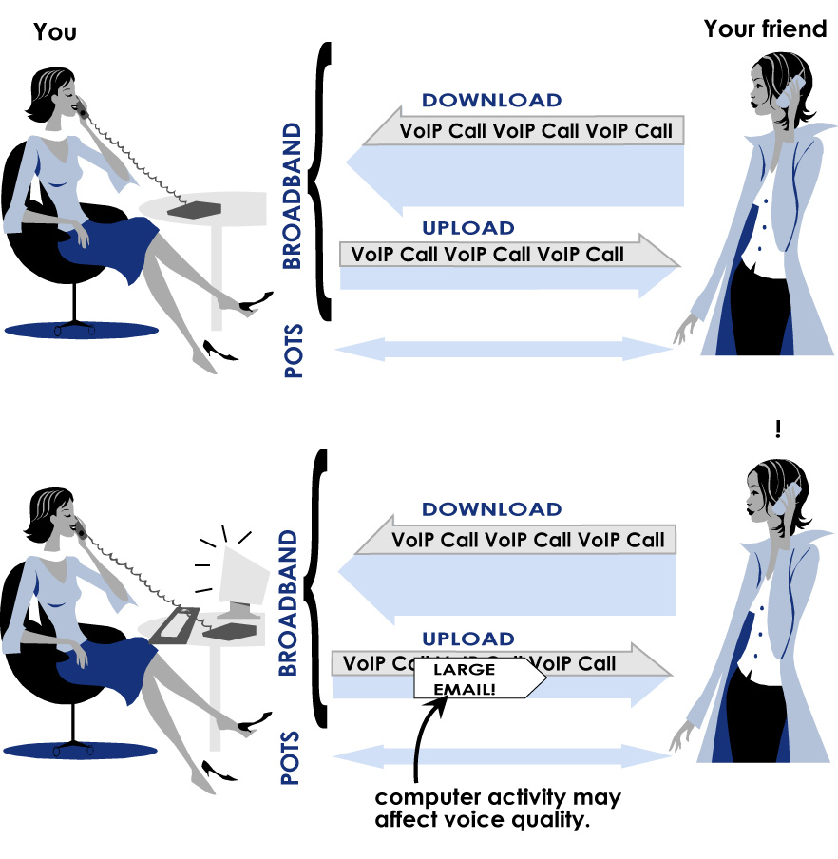

Broadband monthly data usage
VoIP calls consume data as a part of your monthly broadband data usage allowance (just in the same way as emailing and uploading and downloading files does). The Plans of the ISP mentioned above generally mention this figure as well. As a typical example:
Light usage | 200 MB
Medium usage | 600 MB
Heavy usage | 20 GB (i.e. 20,000 MB)

So how much data is consumed in a VoIP call? VoIP calls can typically use 10 MB to 40 MB* from your quota for every hour of calls.
The amount of data is dependant on how your equipment digitises your voice. (Generally, the larger the amount, the better speech quality).
With some accounts this can be controlled by you. There is a trade-off between quality and monthly data usage.
*approximate figures
So what you need to consider is:
Some ISPs only count downloads in your usage allowance (ONE side of the conversation).
Others count both uploads and downloads (BOTH sides of the conversation).
- How long do I talk each month on the phone?
- Does the broadband service have an unlimited download quota (so no problem), otherwise:
If you exceed your monthly data usage, then either you will not be able to make further VoIP calls or alternatively the VoIP calls could increase your broadband bill.
- Is the monthly download/upload data quota sufficient for a VoIP service?
- What will happen to my VoIP service if my broadband service exceeds its monthly quota?

You don’t have broadband? How do you go about finding an ISP who supplies broadband?
- Is broadband available to you in your area? Visit
broadband CHOICE (www.broadbandchoice.com.au)to find out.
Broadband can be provided in different ways - ADSL, cable, wireless or satellite.
- Ask your friends who have broadband and about their experiences.
- Shop around. Go to some electronic retail stores. Visit some websites such as Choice magazine (www.choice.com.au), broadband CHOICE (again) or go to the individual broadband provider websites.

If you already have broadband, you will need to determine that it is suitable
- Is my connection speed adequate? (see ‘Broadband Speeds’ above)above)
A useful website called ‘TestYourVoIP’ at
www.testyourvoip.com will make a VoIP call from wherever you are to one of several test locations and report the results.
This test can be carried out also while downloading or uploading a file to the internet to illustrate the impact on your VoIP call.

Questions to ask the ISP
- Are there any restrictions on the VoIP service or the provider that I choose? Are all the VoIP services handled the same way?
- Can the ISP offer any assurance of service?
Further information
- DCITA Broadband Now www.broadbandnow.gov.au
- Whirlpool www.whirlpool.net.au (a technical website on Australian broadband, including information on VoIP)
- Broadband speed tests: ‘Oz Broadband Speed Test’ at
www.ozspeedtest.com or the ‘Internet Connection Center’ at www.pcpitstop.com/internet
- Choice Magazine - go to ‘Internet connection options’ at
www.choice.com.au

4 Deciding on a VoIP service provider
By this stage you have decided what you are looking for in a VoIP service and that your broadband is up to scratch. With the wide selection of VoIP service providers to choose from, a little homework is required. Armed with the knowledge of what is available, you are now ready to find a VoIP service provider that is right for you.

How do you go about finding a VoIP service provider?
- Ask your friends who already use VoIP services about their experiences.
- Shop around. Go to some electronic retail stores. Visit some websites such as vOip chOice at www.voipchoice.com.au, The Aussie VoIP List at www.marketclarity.com.au or go to the individual VoIP service provider websites.
Some providers may ‘bundle’ broadband and VoIP services into one package.

What questions to ask about the VoIP service provider
- Is there somewhere I can see the VoIP service in operation before I purchase it?
- Is there a trial period to test it out?
- Can the VoIP service provider offer any assurance of service?
You may wish to consider factors that may be affected by where your VoIP service provider is located. If located overseas:
The quality of the sound is related to a concept known as Quality of Service (or QoS). If the provider is located overseas, there would be some extra delay in the conversation and the quality may suffer.
- Would the voice quality of my calls be affected (what you sound like and what you hear)?

- In time of dispute, who and how do I contact someone for assistance? In which country would any disputes be resolved?
Customer contracts are dependant on which country the service provider’s business is located.
- Will my contract be covered by Australia consumer law?
- Would my bills be in Australia dollars and if not, would they be subject to currency fluctuations?
- How are ‘000’ and ‘106’ calls to the emergency service operators handled?
Further information
- Communications Alliance VoIP factsheet ‘What you should tell your customers about their Internet Telephony/VoIP Service’
www.commsalliance.com.au/projects/voip
- Australian Communications and Media Authority (ACMA) ‘Internet Calls (VoIP) Homepage’
www.acma.gov.au/WEB/STANDARD//pc=PC_100550
- phonechoice ‘Voice over IP’
www.phonechoice.com.au/index.cfm?Section=Voip
- Wikipedia – Voice over IP
http://en.wikipedia.org/wiki/Voip
- Choice Magazine – go to ‘Internet phone calls’ at
www.choice.com.au

5 Connecting it all up
There are a few options in how you connect up your VoIP service in your residence or home office. Some typical installations are covered below, together with a few questions to consider to help you decide how you may want to use your VoIP service.
The figures in this section illustrate three possible arrangements. You can continue to use your existing telephone handset. You can use a new VoIP phone. You can even have your VoIP phone revert back to your normal phone if your broadband or VoIP service becomes unavailable.
Find out from the VoIP service provider what options are possible and how they can meet your needs.

Things to consider
- How does the VoIP service work alongside my existing phone service? Do I need to purchase software or extra equipment such as an adaptor for my existing phone (called an ‘analogue telephone adaptor or ‘ATA’) to use the VoIP service? Can I continue to use my existing handset?
You may need to check what equipment you can use with your ISP.
- Does my existing broadband modem have the necessary capabilities or do I need to upgrade (either from the broadband service provider/VoIP service provider or purchase from a retail outlet)?
Some older broadband modems do not have connections for VoIP phones.
Newer broadband modems can also improve the voice quality by prioritising the call on your home network.
If you have faster broadband (e.g. ADSL2) or computer usage is low while you are on the phone, then voice quality is less affected.
- Is it simple to install and easy to use? For instance, will I need to change my settings to get good voice quality?

- Can I still use my existing ‘POTS’ service for dialling out and receiving calls?
- Am I restricted in what telephone handset or what software I can use?
- Do I need to have a telephone socket where I intend to locate the telephone (e.g. next to a computer).

You will need to consider where your equipment is to go and where you want to use your phone.
If you do not have a phone socket where you need it, there are some options available:
- You can use a cordless phone.
- You can extend for home network (either more cabling, a wireless connection or you can use your electrical wiring as a part of your network (this last option is called Broadband over Powerline or ‘BPL’).
As with all calls, the quality of the equipment, especially the handset can have a large impact on the voice quality.

Connecting up to VoIP service
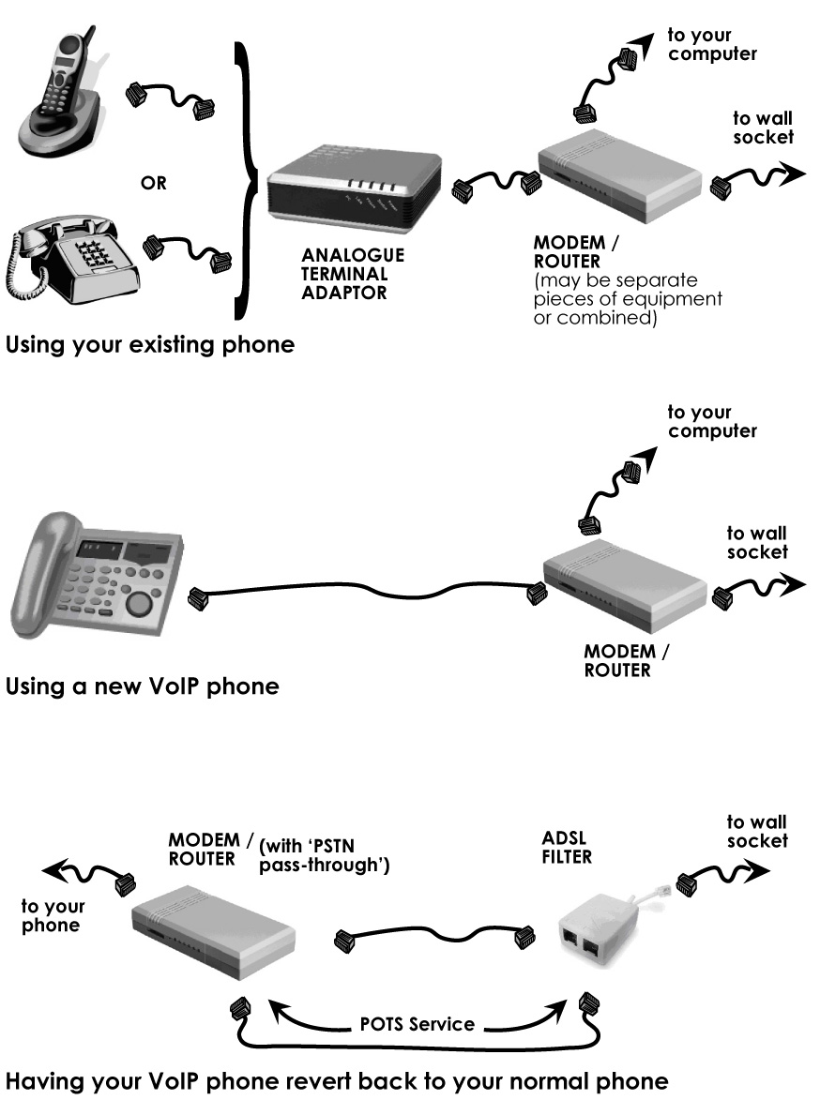

6 Using your VoIP service
Generally there is little difference in making and receiving calls using a VoIP service but there are a few things that need your attention. Also, if something does go wrong, there are a few more issues to consider to determine the problem.
‘Dial’ tones and ‘engaged’ signals will likely be different from the ones that you are used to.

Finding phone numbers
- Is there an operator that I can call for directory assistance and for operated assisted calls?
- Does my number appear in a directory listing such as the White Pages®? What are the charges? What if I don’t wish to have my number listed anywhere?

How to go about solving faults and problems
Troubleshooting problems with a VoIP service has a little more in common with fixing computer-related problems than fixing a phone. Here are some suggested steps to follow:
If a call does not connect, or suddenly drops out, hang up and call again.
If your VoIP service is not working properly:
- check that your internet connection is working properly by browsing the internet from your computer.
- check that the power is on in each piece of equipment.
- check that all the cables are connected properly.
- try turning the power off and on again for each piece of equipment (also called ‘rebooting’, just like a computer).
- check that your equipment has been setup correctly.
If the voice quality is suffering, for example you are getting noise or distortion in your calls (or the person you are speaking with has problems understanding you):

- Check for other activity on your computer or home network, for example downloading files from the internet, using file and music sharing programs, sending emails with large attachments.
Chopped up or intermittent speech is more likely on lower broadband speeds or lower quality ISP networks.
The person you are calling may be experiencing worse voice quality than you (because of the slower broadband upload speeds).
- If there is irritating noise or ‘static’, it may be due to interference from other nearby devices (maybe noticed if you are using a cordless phone).
- Check your handset. If possible, plug in a different handset or trying using your handset on another phone line.
The service or equipment of the person you are calling may be the cause of the poor quality or noise.
- If you are using loudspeakers on a computer, try using a headset or a handset.
If the problem still exists, you can:
- Check the fault-finding procedures in your manuals.
- If you think it is something to do with your VoIP service, seek assistance from your VoIP service provider.
- If you think it is something to do with your broadband service, seek assistance from your ISP.

General safety and privacy/security issues
Telephone users should be aware of two safety issues when using phones, whether the phones are held in the hand or are headsets. One is the use of telephones during thunderstorms and the other is the possibility of experiencing acoustic shrieks. Further information may be found in the Telstra White Pages® or at
www.telstra.com.au/thunderstorms/index.htm
If using a computer in the home or office, normal security and privacy measures should be considered including the use of log-in passwords, virus protection, provision of a firewall and backing up of address books and other sensitive information.

7 Customer service and your rights
Customer service is an essential part of any business. You should have access to account and technical assistance when the need arises. However, as new types of VoIP and other communications services emerge, the regulation and legislation applying to them is not always immediately clear. It is important you feel comfortable with the level of protection and guarantees your service provider offers you.
As a customer of a service provider operating in Australia, you have certain rights when using a telephone service. The following information applies to telephone services provided in Australia, including VoIP phone services.

Customer service
- How do I contact customer service? Between what times can I call? Are there help lines and test numbers available?
- Where can I get further information or user manuals for my phone service and my telephone equipment?

Consumer protection
The ACIF factsheet An introduction to Consumer Codes provides information on consumer protections that industry provides regarding:
- advertising the prices, terms and conditions of services
- consumer contracts
- billing
- customer transfer
- credit management
- complaints handling.
- What are the terms and conditions of the VoIP services? Are the contractual arrangements to use the telephone service fair and easily understood and how can I get a copy?
- Can the VoIP service provider help me manage my telephony spending?
- Does the provider have a policy to help me if I get into financial difficulty?
The CSG specifies the times in which standard telephone services must be installed and repaired (see link below for more information).
- Is the telephone service covered by the Customer Service Guarantee (CSG)?

- What is the privacy policy of the provider? Where can I get a copy?
The TIO is a free and independent alternative dispute resolution scheme for small business and residential consumers in Australia with unresolved complaints about their telephone or internet services. It is an office of last resort.
- How do I make a complaint? Does the provider have a complaint handling policy?
- Is the service provider a member of the Telecommunications Industry Ombudsman (TIO)?
- Is the service provider a member of Communications Alliance?
- Does the provider protect you from unaaceptable conduct in relation to a telephone sex service.
- Can the provider assist you if you are the recipient of life threatening or unwelcome calls?
Further information
- Communications Alliance factsheets
An Introduction to Consumer Codes
www.commsalliance.com.au/about_us/factsheets
- Information on industry compliance with Consumer Codes
www.commsalliance.com.au/documents/code_compliance
- ACMA Consumer Information Centre
www.acma.gov.au/WEB/STANDARD//pc=PC_2016
- ACMA The Customer Service Guarantee
www.acma.gov.au/WEB/STANDARD//pc=PC_2017
- ACMA Internet Calls
www.acma.gov.au/WEB/STANDARD//pc=PC_100550
- The Telecommunications Industry Ombudsman
www.tio.com.au
- ACCC Phones website
www.accc.gov.au/content/index.phtml/itemId/3869
- Department of Communications, Information Technology and the Arts (DCITA)
www.dcita.gov.au/communications_for_consumers/internet
- Choice magazine (by the Australian Consumers’ Association)
www.choice.com.au

Your service details
ISP
Your account details:
Account contact no:
Technical assistance:
VoIP Service provider
Your account details:
Account contact no:
Technical assistance:
VoIP test line:

Feedback
Communications Alliance welcomes and encourages feedback. Send your comments to info@commsalliance.com.au .
This publication is available at www.commsalliance.com.au in a number of formats. Limited hardcopies are available on request.
This booklet suggests helpful links to other websites and Communications Alliance does not endorse and take any responsibility for the information on these websites.
The information is this booklet reflects the telecommunications environment and the types of VoIP services being provided at the time of publication. It is not intended to preempt any of the outcomes of the work being carried out.
The booklet will be regularly reviewed to reflect the changing nature of the telecommunications environment.

Overview of Communications Alliance
Communications Alliance was formed in 2006 from the merger of the Australian Communications Industry Forum (ACIF) and the Service Providers Association (SPAN) to provide a unified voice for the Australian communications industry and to lead it into the next generation of converging networks, technologies and services.
In pursuing its goals, Communications Alliance offers a forum for the industry to make coherent and constructive contributions to policy development and debate.
Communications Alliance seeks to facilitate open, effective and ethical competition between service providers while ensuring efficient, safe operation of networks, the provision of innovative services and the enhancement of consumer outcomes.
It is committed to the achievement of the policy objective of the Telecommunications Act 1997 - the greatest practicable use of industry self-regulation without imposing undue financial and administrative burdens on industry.

Communications Alliance work in VoIP
Communications Alliance is actively involved in assisting the Australian telecommunications industry in the introduction of services such as VoIP. Our Working Committees and Groups are working on many activities including quality of service (QoS) for VoIP and QoS for the Australian IP networks.
Communications Alliance would like to recognise the work carried out by its VoIP Working Group in developing this booklet and the contributions by industry members.

Published by:
COMMUNICATIONS ALLIANCE LTD
Level 9, 32 Walker Street, North Sydney, NSW 2060 Australia
Mailing address: PO Box 444, Milsons Point, NSW 1565

T 61 2 9959 9111
F 61 2 9954 6136
TTY 61 2 9923 1911
E info@commsalliance.com.au Copyright 2007
www.commsalliance.com.au June 2007, 2nd edition
ABN 56 078 026 507 ISBN No 1 74000 362 4

