INDUSTRY GUIDELINE
G630:2020
Accessibility of Payphones

G630:2020 Accessibility of Payphones Industry Guideline
First published as G630:2006
Communications Alliance Ltd was formed in 1997 to provide a unified voice for the Australian communications industry and to lead it into the next generation of converging networks, technologies and services.
Disclaimers
- Notwithstanding anything contained in this Industry Guideline:
  - Communications Alliance disclaims responsibility (including where Communications Alliance or any of its officers, employees, agents or contractors has been negligent) for any direct or indirect loss, damage, claim, or liability any person may incur as a result of any:
    - reliance on or compliance with this Industry Guideline;
    - inaccuracy or inappropriateness of this Industry Guideline; or
    - inconsistency of this Industry Guideline with any law; and
  - Communications Alliance disclaims responsibility (including where Communications Alliance or any of its officers, employees, agents or contractors has been negligent) for ensuring compliance by any person with this Industry Code/Guideline.
- The above disclaimers will not apply to the extent they are inconsistent with any relevant legislation.
Copyright
© Communications Alliance Ltd 2020
This document is copyright and must not be used except as permitted below or under the Copyright Act 1968. You may reproduce and publish this document in whole or in part for your or your organisation’s own personal or internal compliance, educational or non-commercial purposes. You must not alter or amend this document in any way. You must not reproduce or publish this document for commercial gain without the prior written consent of Communications Alliance. Organisations wishing to reproduce or publish this document for commercial gain (i.e. for distribution to subscribers to an information service) should apply to Communications Alliance by contacting the Communications Alliance Commercial Manager at info@commsalliance.com.au.
INTRODUCTORY STATEMENT
The Accessibility of Payphones Guideline (G630:2020) (the Guideline) replaces the G630:2006 Accessibility of Payphones Industry Guideline.
Background
In 2003, according to the Australian Bureau of Statistics (ABS), some 3.95 million people in Australia or 20 percent of the population, living in households or cared accommodation had a disability (ABS, 2003, Survey of Disability, Ageing and Carers). The survey also found that the likelihood of having a disability generally increased with age. In a recent report, the Productivity Commission predicted that one quarter of Australians will be aged 65 or over within the next 40 years. (Productivity Commission, Economic Implications of an Ageing Australia, November 2004). The impact of both Reports is the likelihood of a significant and growing number of Australians with particular access needs for whom communications equipment, including payphones, must be accessible.
Australian Communications Authority Report
The review of payphone policy was previously part of a larger review of the universal service obligation (USO), as required under s. 159A of the Telecommunications (Consumer Protection and Service Standards) Act 1999 (Cth). (The provision of the USO includes the obligation on the USO provider to provide reasonable access to payphones). The Report was provided to the Minister in February 2004. The third Recommendation of the Report was that:
The Payphone industry and disability peak bodies should consult through an (then) Australian Communications Industry Forum (ACIF) working group, and work together to develop a Payphone Accessibility Code for endorsement by the then Human Rights and Equal Opportunity Commission ( HREOC). Australian Local Government Association (ALGA) and the Property Council should be invited to be involved in this ACIF group. The group should look for approaches that
- Maximize reasonable accessibility for people with a disability;
- Are flexible enough so as not to inhibit the overall provision of public and private payphones; and
- Provide certainty to payphone operators that they have met their obligations under the Disability Discrimination Act.
The fourth recommendation of the Report focused on the provision of teletypewriter (TTY) payphone services as a specific area for review by the working group.
The Minister issued a press release welcoming the ACA’s recommendations and saying the Government would consult further on the implementation of the recommendations.
In June 2010, the then Minister of Broadband Communications and the Digital Economy released a policy statement on the future delivery of the USO in the context of the National Broadband Network — that is, the delivery of USO services through contract with Telstra. Currently, Telstra's USO-related statutory and contractual obligations co-exist.
To support payphone reform, the then Minister made five new payphone instruments which commenced on 1 January 2012. At the same time the ACMA also developed Guidelines to support these new payphone instruments.
Regulatory Arrangements
Telecommunications (Consumer Protection and Service Standards) Act 1999
Under the Telecommunications (Consumer Protection and Service Standards) Act 1999, the Universal Service Provider (USP) is required to ‘ensure that payphones are reasonably accessible to all people in Australia on an equitable basis, wherever they reside or carry on business’. This includes ensuring people with disabilities have access to payphones.
Telstra is the USP, including for payphones. The USO does not, however, include the provision of private payphones.
Disability Discrimination Act 1992
The Disability Discrimination Act 1992 (Cth) (DDA) makes it unlawful to discriminate against a person on the grounds of a disability. The objects of the DDA include eliminating, as far as possible, discrimination against people with disabilities and promoting recognition and acceptance within the community that people with disabilities have the same fundamental rights as the rest of the community.
The DDA uses a broad definition of “disability” that includes:
- Physical
- Intellectual
- Psychiatric
- Sensory
- Neurological, and
- Learning disabilities, as well as
- Physical disfigurement, and
- The presence in the body of disease-causing organisms.
The law is administered by the Australian Human Rights Commission (AHRC) and sets out specific areas in which it is unlawful to discriminate. These areas include the provision of goods, services and facilities. An organisation that provides such goods and services is liable for complaint if those goods or services are not accessible to people with disabilities.
The DDA recognises, however, that in certain circumstances, providing equitable access for people with disabilities could cause ‘unjustifiable hardship’ for an individual or organisation providing goods or services.
Where a person with a disability believes they have been discriminated against they can complain to the Commission who will investigate the complaint and, where appropriate, attempt to conciliate a solution between the two parties. Where conciliation is not possible the complainant may take their complaint to the Federal Court or Federal Magistrates Service who have the authority to determine whether unlawful discrimination has occurred and what constitutes ‘unjustifiable hardship’. Nothing contained in this Guideline removes the right of an individual to pursue a complaint under the DDA in relation to a payphone they believe is inaccessible. The Commission also has a role in assisting organisations understand their responsibilities and supporting initiatives aimed at promoting compliance through best practice. While these Industry ‘standards’ or ‘best practice guidelines’ have no force in law the Commission has supported their development in the hope that they will provide a level of access consistent with the requirements of the DDA.
The Guideline is for the design and provision of payphones. The Guideline does not have the force of law and adopting the Guideline does not guarantee fulfilment of legal responsibilities under the DDA, nor does it remove from any institution their obligation to comply with the requirements of that Act or any other relevant legislation. The adoption of Industry Standards is voluntary, but compliance is generally monitored by industry regulators.
The Guideline assists providers supplying or installing new payphones. It also assists providers who are upgrading or renovating existing facilities and who wish to address access issues in the process of upgrading or renovation.
As noted earlier the DDA contains a general provision that allows service providers to claim an 'unjustifiable hardship' if technical or cost issues would result in too onerous a demand.
The Guideline aims to encourage payphone providers to provide payphones that are as accessible as possible to all Australians, and to assist providers to comply with the requirements of the DDA, but it is the responsibility of providers to decide whether or not in particular circumstances, full application of some of the content of the Guideline might cause them an unjustifiable hardship.
It is acknowledged that Australia is a small market and does not manufacture payphones. Payphones are purchased from overseas, where different disability standards apply. The cost could be prohibitive for Australian payphone operators to have payphones specially manufactured to meet Australian requirements and unjustifiable hardship arguments may apply. However, the aim of the Guideline is to, as much as possible, encourage the procurement of compliant equipment as and when it becomes available.
Some providers might develop an Action Plan under the DDA as a strategy to address access to all their payphones over a period of time. An Action Plan can be lodged with the AHRC and makes a positive statement about the organisation’s commitment to addressing access barriers. It can also be used as part of a defence of unjustifiable hardship in the event of a complaint.

2019/20 Revision
In 2019/20, the Guideline was updated to:
- align it with changes made to Australian Standards;
- reflect changes in payphone technology and to allow for future technologies;
- include the National Relay Service (NRS) noting its increased reliance rather than just the telephone typewriter (TTY); and
- ensure references to legislation and standards remain current.

TABLE OF CONTENTS
1 General 2
1.1 Introduction 2
1.2 Scope 2
1.3 Objectives 2
1.4 Guideline review 3
2 Acronyms, definitions AND interpretations 4
2.1 Acronyms 4
2.2 Definitions 4
3 Accessibility guidelines 5
3.1 Siting 5
3.2 Installation 5
3.3 Enclosure 6
3.4 Terminal 6
3.5 Instructions 8
3.6 National Relay Service (NRS) 8
3.7 Payphones in rural/regional areas 9
4 REFERENCES 10
APPENDIX A 11
APPENDIX B 12
Illustrations of Enclosures 12
Half Length Enclosure 12
PARTICIPANTS 14

General

Introduction
    - Section 112 of the Telecommunications Act 1997 (the Act) sets out the intention of the Commonwealth Parliament that bodies and associations representing sections of the telecommunications industry develop industry codes relating to the telecommunications activities of participants in those sections of the industry.
    - The development of the Guideline has been facilitated by Communications Alliance through a Working Committee comprised of representatives from the telecommunications industry, Payphone providers and consumer groups.
    - The Guideline should be read in the context of other relevant codes, guidelines and documents.
    - The Guideline should be read in conjunction with related legislation, including:
- the Act;
- the Telecommunications (Consumer Protection and Service Standards) Act 1999 (Cth); and
- the Disability Discrimination Act 1992.

Scope
    - The Guideline is for use by payphone providers and telecommunications equipment suppliers in the acquisition, provision and installation of Payphones.

Objectives
    - The objectives of the Guideline are to provide guidance in the design and provision of Payphones to:
- maximise accessibility for people with a disability, such as consideration of the handset design, mounting height and siting, etc.;
- ensure sufficient flexibility so as not to inhibit the overall provision of public and private Payphones;
- provide guidance to payphone operators in meeting their obligations under the Disability Discrimination Act 1992; and
- have regard to overseas requirements in the design and provision of Payphones.

Guideline review
    - The Guideline will be reviewed every 5 years, or earlier in the event of significant developments that affect the Guideline or a chapter within the Guideline.

Acronyms, definitions AND interpretations

Acronyms
For the purposes of the Guideline:
NRS
means the National Relay Service.
TTY
means telephone typewriter.

Definitions
For the purposes of the Guideline:
Enclosure
means a structure in which the Payphone is housed.
NOTE: An enclosure can include a full length booth, a half length booth or a wall mounted booth. Not all Payphones are housed in an Enclosure. (see Appendix B for illustrations of Enclosures.
Mobility Aid
includes, but is not limited to, a walking frame, a long cane, a wheel chair or a motorised scooter.
Payphone
means a terminal that is:
- used to make voice calls or equivalent; and
- has facility to accept payment using Australian currency, prepaid phone cards or other payment methods such as credit cards.
Public Payphone
means a Payphone that is available to the public.
NOTE: Public Payphones available to the public are located in areas such as shopping centres, airports and footpaths.
Terminal
means a unit including a handset, dial pad and facility for payment.

Accessibility guidelines

Siting
    - If the Enclosure is sited on a public footpath, it should be sited so as to maintain as clear an access path as possible and should:
      - be oriented to face away from the kerb, or parallel to it;
      - have a minimum of 1.2 metres unobstructed travel path on the building side of the pedestal and no closer than 300 mm from the kerb;
      - if mounted on a pedestal, have the pedestal oriented to be at right angles to the kerb;
      - not be near cross walks;
      - if situated in, or close to street furniture or fixtures such as bus shelters, seating or telegraph poles, have unimpeded access; and
      - where possible, be located away from traffic noise.
NOTE: Consider full booth and / or volume control when the Enclosure is sited near heavy traffic.
    - If the Enclosure is mounted on a wall or other surface, it should be mounted so that:
      - a person can move freely around the Payphone;
      - it is located so it will not impede other customers; and
      - it Is located so it can be easily accessed by a person using a Mobility Aid.
NOTE: Enclosures should not be located at the top of stairs or in a narrow passageway.
    - When the Enclosure is sited, it should be in a location with good ambient lighting.

Installation
    - The minimum height for the lowest point of the Terminal (including shelf) should be 700 mm from the floor.
    - The maximum height from the floor to the highest operable part of the Terminal (inclusive of any future user operable technology features) should be:
      - if the clear floor space only allows forward approach, 1220 mm; or
      - If the clear floor space allows parallel approach, 1350 mm.
    - If the Terminal is mounted on a bench or counter the maximum height for the Terminal should be lessened by 1 cm for every 2 cm the Terminal is set back from the edge of the counter or bench.
    - If a Payphone is mounted in a half length booth, there should be sufficient surrounding space to allow for both front and side access (from both sides) for Mobility Aids

Enclosure
Guidelines for the Enclosure (whether full length or half length) are:
- The base should be level with the surrounding surface;
- Lighting should be provided to a minimum of 2oo lux at the Terminal;
- For full length Enclosures, the entry should be at least 800 mm in accordance with AS 1428.2; and
- Where a pedestal booth is used, the width of the pedestal on which the booth sits should reflect, as closely as possible, the width of the booth.

Terminal
    - The Terminal should have volume control, as follows:
      - there should be clear indication on the Terminal that the volume can be adjusted. It is desirable that a volume control be indicated by use of a tactile marking;
      - there should be a graduated raise in volume up to permissible Australian standards;
      - the volume control should reset to normal at the termination of a call; and
      - the volume must be adjustable in accordance with AS / CA S004:2013
    - If fitted, the coin entry / card reader should be:
      - a straight slot for coin entry or a tap area for contactless card readers; and
      - easy to locate and orient by touch alone.
    - For Payphones with a physical button keypad, the keypad should have:
      - dialing via a push button keypad;
      - a standard number layout;
      - a tactile orientation mark on the number 5 button;
      - audible and, if possible, visual feedback on key depression;
      - keys that are recessed or concave;
      - lettering on keys that use open typeface fonts such as Arial or other sans serif fonts such as Tiresias; and
      - keys that provide a minimum luminance contrast of at least 30%, with the best contrast possible, avoiding polished surfaces.
    - For Payphones with an additional touchscreen incorporated keypad, the keypad should have:
      - a standard number layout;
      - audible and, if possible, visual feedback on key depression;
      - lettering on keys that use open typeface fonts such as Arial or other sans serif fonts such as Tiresias; and
      - keys that provide a minimum luminance contrast of at least 30%, with the best contrast possible, avoiding polished surfaces.
    - Keypads must be in accordance with AS / CA S002:2010.
    - If there are function keys on the Terminal, there should be a clear indicator of their function.
    - If fitted, the handset should be of ergonomic design.
    - The handset cord should be a minimum of 735 mm long.
    - If there is no handset fitted, the speaker box must include an inductive hearing aid coupler in accordance with AS / ACIF S040:2001.
    - If the Terminal has a display screen, the screen:
      - should be set so that it can be viewed from an angle of up to 30 degrees;
      - should have 30% luminosity;
      - should provide good contrast;
      - the text on the screen should use open typeface fonts such as Arial or other sans serif fonts such as Tiresias. The size of the font should be a minimum of 12 point but preferably14 point; and
NOTE: The text should preferably use black lettering on a white background. If using colours, the text should be in a strong primary colour (such as maroon or blue) against a pale background colour (such as beige or pale yellow.)
      - It is desirable to have audio output to match the visible information.
    - If fitted, the coin refund chute should have tactile orientation.
    - If fitted, the card reader chute should be of sufficient size and design so that cards should protrude at least 2 cm to assist the retrieval of the card, or otherwise allow the card to be easily retrievable.
    - The Terminal should give an audible indicator;
      - when credit is about to expire; and
      - for requesting the removal of a prepaid card on completion of the call.

Instructions
    - Instructions should be adjacent to, or immediately above the keypad.
    - Instructions should:
      - be a minimum of 12 point font, but preferably 14 to 16 point font;
      - use clear graphics and plain English to indicate the basic operation of the payphone;
      - be in a combination of lower and upper case type;
      - use open typeface text fonts such as Arial or other sans serif fonts such as Tiresias; and
      - if behind protective covering (perspex or glass) be on non- reflective material.
    - Greyscaling should be used before final format.
NOTE: If instructions are provided in colours, greyscaling means reprinting the instructions in black and white to ensure their readability by people with colour vision impairment.
    - Payphone providers should have additional instructions on the use of their payphones on their website or otherwise available on request, including available in alternative formats.

National Relay Service (NRS)
    - In the selection of sites for NRS payphones, payphone providers should work with organisations representing deaf, hearing and speech impaired people, to identify appropriate locations for Payphone NRS in metropolitan or regional areas. Priority is to be given to provision of NRS payphones at locations such as medical, judicial and educational institutions, shopping centres and transport terminals.
    - Payphone providers should make information readily available to consumers on the location of the NRS payphones they provide.

Payphones in rural/regional areas
    - When only one payphone is provided in non-urban areas, the payphone should have as many features for accessibility as possible as per this Guideline.
    - When removing or relocating a payphone from a non-urban area, the payphone operator should leave payphones with accessibility features in place.

REFERENCES
Publication | Title
Australian Standards
AS / CA S002:2010 | Analogue interworking and non-interference requirements for Customer Equipment for connection to the PSTN
AS / CA S004:2013 | Voice performance requirements for Customer Equipment
AS / CA S040:2001 | Requirements for Customer Equipment for use with the Standard Telephone Service - Features for special needs
AS 1428.2 – 1992 (Reconfirmed 2015) | Design for access and mobility - Enhanced and additional requirements - Buildings and facilities
International Standards
28 CFR Part 36 | Code of Federal Regulations - Title 28: Judicial  Administration - Part 36: Nondiscrimination on the basis of disability by public accommodations and in commercial facilities.  (regulation made under the Americans with Disabilities Act 1990)
Legislation
Disability Discrimination Act 1992 (Cth)
Telecommunications (Consumer Protection and Service Standards) Act 1999 (Cth)

APPENDIX A
Siting Guideline (not to scale)

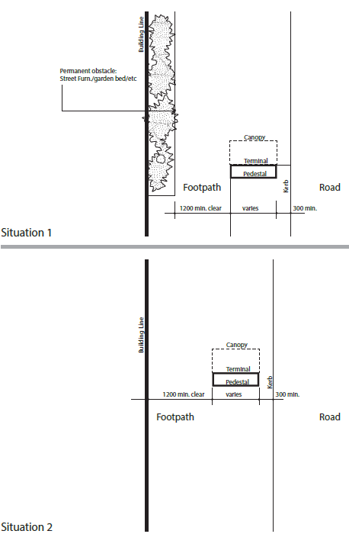

APPENDIX B
Illustrations of Enclosures
Half Length Enclosure
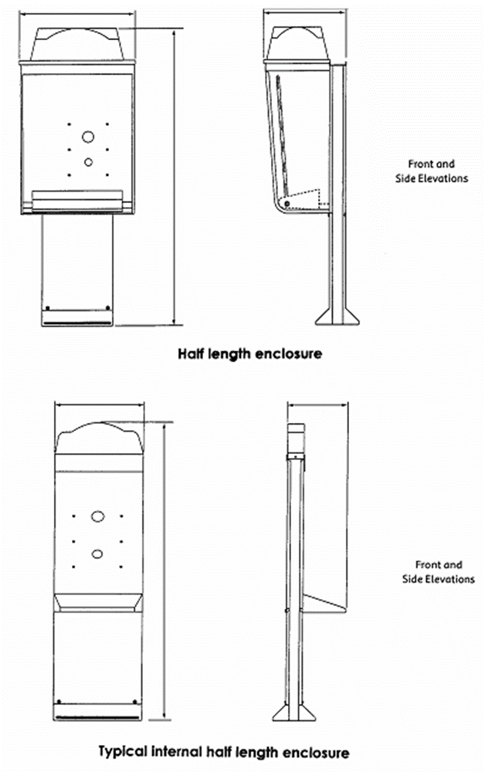
  - Full Length Enclosure
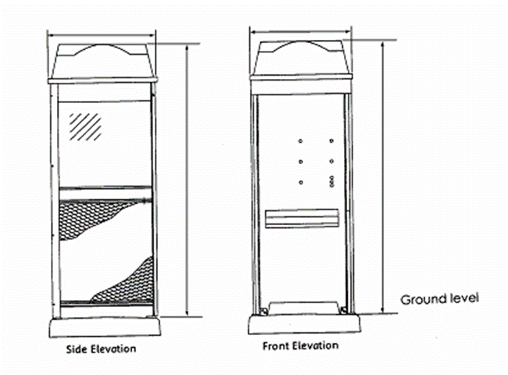
PARTICIPANTS
The Working Committee responsible for the revisions made to this Guideline consisted of the following organisations and their representatives:
Organisation | Membership | Representative
ACCAN | Voting | Wayne Hawkins
Synergy Asset Management | Voting | Rick Anderson
Telstra | Voting | David Smith
Telstra | Non-voting | Brendan O’Toole
Craig Purdon of Communications Alliance provided project management support.

Communications Alliance was formed in 1997 to provide a unified voice for the Australian communications industry and to lead it into the next generation of converging networks, technologies and services.
In pursuing its goals, Communications Alliance offers a forum for the industry to make coherent and constructive contributions to policy development and debate.
Communications Alliance seeks to facilitate open, effective and ethical competition between service providers while ensuring efficient, safe operation of networks, the provision of innovative services and the enhancement of consumer outcomes.
It is committed to the achievement of the policy objective of the Telecommunications Act 1997 - the greatest practicable use of industry self-regulation without imposing undue financial and administrative burdens on industry.

